The Sea Monster  
Para floripon. De axel.

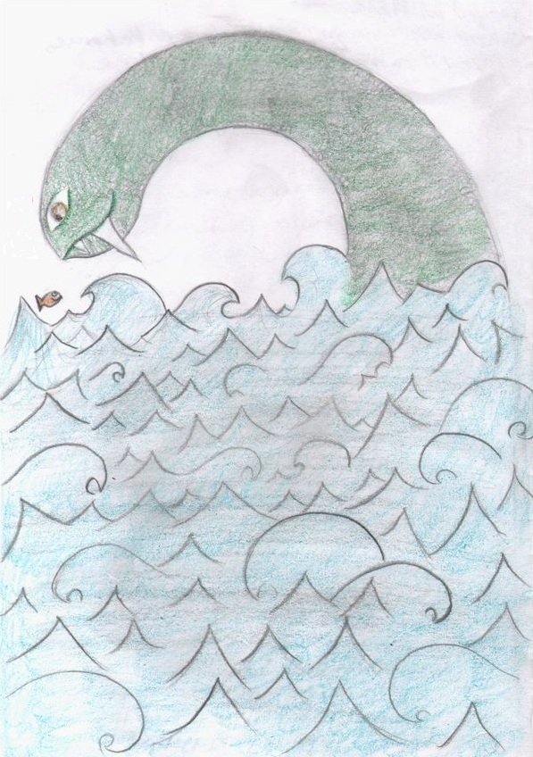

A long time ago, deep down in the sea  
there were no fishies, sharks, no whales, only floppy.

For a very long time, you were all by yourself.  
You had no idea there was somebody else.

You wanted a hug, so you searched far and wide,  
yet you could find no one, only the tide.

When you’d see fishies playing in the reef,   
you’d smile real big, then they’d see your sharp teeth.

They’d all swim away and you’d feel really blue,  
but then one dark night I came across you.

I was not afraid nor did I swim away,  
in fact I told you that I’d like to stay.

I taught you math & you showed me Bieber,  
and while Khan would be proud, I know I’m no Belieber.

I’ll love you forever, as deep as the sea,  
your big brother, I’ll always be.

Wherever you go, you’ll always be home,  
cause I’ll swim by you, never alone.